TOLER Elementary
PRINCIPAL/PARENT CHAT
August 28, 2020

Agenda

- Today’s presentation is about online learning.

- We are not finalizing a plan for onsite learning at this time because we do not know what the conditions will be when we return to campus

What to Expect the First Week August 31- September 4
Students, parents, and teachers will be participating in training modules to strengthen for online learning. Teachers will meet with students for one hour every day. Parent Learning Modules are linked here: Parent Learning Menu.
The District will continue to provide ongoing training modules throughout the year based on parent input.

Welcome Week Activities for Students
As teachers engage in professional learning, students will have access to differentiated, standards-based activities that build skills for online learning, develop social emotional skills, engage in content standards and provide an opportunity for voice and choice.
These stand alone, student-centered activities will be distributed by teachers through their online platforms.

Welcome Week Activities Overview

CLEVER ACCESS FOR PARENTS This link is to assist you with signing into Clever in order to access the district’s online learning platforms for your student.
• English: https://www.youtube.com/watch?v=CWOX3BTAG68&t=9s
• Spanish: https://www.youtube.com/watch?v=7vJGcRTKj-E
• Vietnamese: https://www.youtube.com/watch?v=n8wi5HOdbxU
• Tagalog: https://www.youtube.com/watch?v=QqffUqsoimM
• Arabic: https://www.youtube.com/watch?v=xI_xwkzUFaQ
Instructional Minutes

Families can expect:
- A six-hour school day with customized learning experiences for each student

- All students will have daily, live interaction with their teachers

- Custom learning experiences will be based on student needs and will include daily live, online instruction (up to three hours), independent learning (at least two hours), working with other students in small groups or participating in educator office hours (at least one hour)

- All students will receive instruction in reading, writing, mathematics, science, social studies, physical education, the arts and English language development if your child is a second language learner

- Students will receive grades to measure their progress

Daily Instructional Minutes
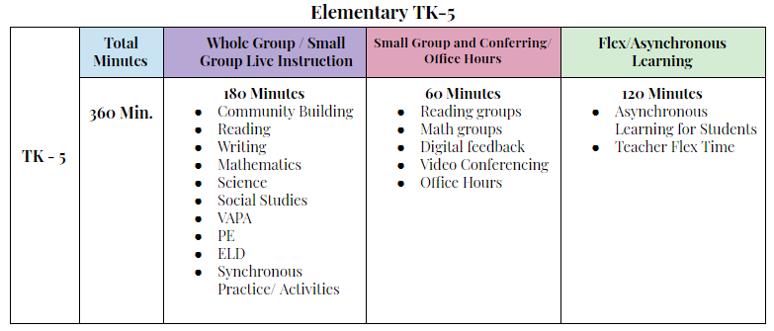
School Hours

- School Hours will be 9:00 am - 3:00 pm M-F
- No Minimum Day During Online Learning

- Wellness Breaks During Morning and Afternoon Sessions

- Lunch Break Will Be 12:30pm - 1:15 pm

Individual Classroom Schedules Will Be Shared By Your Teacher

Technology & Device Management

- SDUSD continues to provide free Wi-Fi service to families that need it.
- As a 1:1 District, schools will be issuing a Chromebook to students to ALL new students and those who did not receive one during distance learning.
- For Chromebook care, click through these informational slide: English Spanish
- For Chromebook troubleshooting tips click below.
- English | Spanish
- Students and parents can access all online platforms by signing into Clever. After signing in, look for the online platforms section. Here students will find links to zoom calls, assignments and grades. Watch this video for how to sign in to Clever.

Need help with your district Chromebook or other devices used for Online Learning?
For technical support, call the Online Learning Technical Support Line at (619) 732-1400.
Hours of operation are 8 am - 5 pm, Monday - Friday.
Saturday Hours: 9 am - 1 pm September 1 - October 31
Note: Many issues with Chromebooks can be resolved by restarting the device. Students and parents can refer to the resources provided on this page for simple steps that will resolve the majority of issues not related to damage.

Special Education

- Students with disabilities will receive live instruction from their general education classroom teacher, their education specialist and their related service providers via video conferencing in both whole group and small group as well as office hours to connect with teachers if they still have questions or need more support.

- Accommodations and assistive technology will be provided online as outlined in a student’s IEP.

- Families can request a meeting with the IEP team to determine how IEP services will be delivered in online learning.

Attendance

- Teachers will take student attendance daily and attendance will be based on both synchronous and asynchronous participation. If your student is absent please email your student’s teacher.
Food Services

- Beginning Monday August 31, Grab & Go meals will be served from 82 sites throughout the district.

- Toler is a primary serving site so you will be able to come to Toler for meal pickup Monday through Friday. This is both a drive through and walk up service.

- Breakfast and Lunch will be served from 12 noon until 2 pm.

Notes:

During Online Learning, district employees will be working remotely.

Childcare
We will keep you informed of any child care opportunities that we learn about
- One parent suggested that you check into The Boys and Girls Club
- Toler PrimeTime will be offering virtual after school care during online learning
Contact Toler Primetime at abradshaw@saysandiego.org for application and information.
- SAN DIEGO ESSENTIAL WORKERS & AT-RISK POPULATIONS CAN NOW ACCESS FINANCIAL ASSISTANCE FOR CHILD CARE SERVICES THROUGH SEPTEMBER 30, 2020 Please contact the Child Care Referral Line at 1-800-481-2151 or by email at myreferral@ymca.org to get a list of child care providers located in San Diego County. Having a provider will speed up your approval for child care subsidy.
*At-Risk Populations include: children at risk of abuse, neglect, or exploitation; children eligible through Emergency Child Care Bridge Program for Foster Children; families experiencing homelessness, or children of domestic violence survivors.

New Link for Toler website:

https://www.toler.sandiegounified.org/

Accessing PowerSchool Parent Portal https://powerschool.sandi.net/public/
Once on the site, click on Create Account You will need your child’s Access ID (AD) Username and Password. Your child’s teacher provides you with your student’s AD.

Toler Office Contacts:

School Secretary: Deborah Stewart dstewart2@sandi.net

School Enrollment Clerk: Nora Pradel npradel@sandi.net

School Nurse: Kori King kking@sandi.net (Fridays)

Health Tech: Carmen Rodriguez crodriguez5@sandi.net (M, T, W, TH)

BSS: Aaron Ferguson: aferguson@sandi.net

Principal: Peggy Lewis plewis1@sandi.net

